📄 Test Case: TC61_CanceltheModifiedInwardBill
❌ FAILED:
[2026-03-13 15:10:14] ? Exception Occurred: unexpected alert open: {Alert text : Could not get a token for application.Fininfra}
(Session info: MicrosoftEdge=145.0.3800.97): Could not get a token for application.Fininfra
Build info: version: '4.38.0', revision: '6b412e825c*'
System info: os.name: 'Windows 11', os.arch: 'amd64', os.version: '10.0', java.version: '17.0.12'
Driver info: org.openqa.selenium.edge.EdgeDriver
Command: [9413abfc014089342962ddda1795fa4a, getPageSource {}]
Capabilities {acceptInsecureCerts: false, browserName: MicrosoftEdge, browserVersion: 145.0.3800.97, fedcm:accounts: true, goog:processID: 1932, ms:edgeOptions: {debuggerAddress: localhost:51601}, msedge: {msedgedriverVersion: 145.0.3800.97 (f4c49d5241f1..., userDataDir: C:\Users\chris\AppData\Loca...}, networkConnectionEnabled: false, pageLoadStrategy: normal, platformName: windows, proxy: Proxy(), se:cdp: ws://localhost:51601/devtoo..., se:cdpVersion: 145.0.3800.97, setWindowRect: true, strictFileInteractability: false, timeouts: {implicit: 0, pageLoad: 300000, script: 30000}, unhandledPromptBehavior: dismiss and notify, webauthn:extension:credBlob: true, webauthn:extension:largeBlob: true, webauthn:extension:minPinLength: true, webauthn:extension:prf: true, webauthn:virtualAuthenticators: true}
Session ID: 9413abfc014089342962ddda1795fa4a
↳ Reason: ❌ ❌ Exception Occurred: unexpected alert open: {Alert text : Could not get a token for application.Fininfra}
(Session info: MicrosoftEdge=145.0.3800.97): Could not get a token for application.Fininfra
Build info: version: '4.38.0', revision: '6b412e825c*'
System info: os.name: 'Windows 11', os.arch: 'amd64', os.version: '10.0', java.version: '17.0.12'
Driver info: org.openqa.selenium.edge.EdgeDriver
Command: [9413abfc014089342962ddda1795fa4a, getPageSource {}]
Capabilities {acceptInsecureCerts: false, browserName: MicrosoftEdge, browserVersion: 145.0.3800.97, fedcm:accounts: true, goog:processID: 1932, ms:edgeOptions: {debuggerAddress: localhost:51601}, msedge: {msedgedriverVersion: 145.0.3800.97 (f4c49d5241f1..., userDataDir: C:\Users\chris\AppData\Loca...}, networkConnectionEnabled: false, pageLoadStrategy: normal, platformName: windows, proxy: Proxy(), se:cdp: ws://localhost:51601/devtoo..., se:cdpVersion: 145.0.3800.97, setWindowRect: true, strictFileInteractability: false, timeouts: {implicit: 0, pageLoad: 300000, script: 30000}, unhandledPromptBehavior: dismiss and notify, webauthn:extension:credBlob: true, webauthn:extension:largeBlob: true, webauthn:extension:minPinLength: true, webauthn:extension:prf: true, webauthn:virtualAuthenticators: true}
Session ID: 9413abfc014089342962ddda1795fa4a

📸 Screenshot:
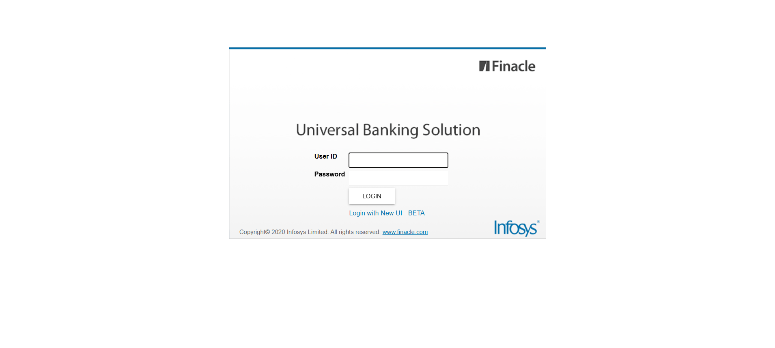
📄 Test Case: TC59_InwardLodgeBill
❌ FAILED:
[2026-03-13 15:08:14] ? Exception Occurred: unexpected alert open: {Alert text : Are you sure you want to logout?}
(Session info: MicrosoftEdge=145.0.3800.97): Are you sure you want to logout?
Build info: version: '4.38.0', revision: '6b412e825c*'
System info: os.name: 'Windows 11', os.arch: 'amd64', os.version: '10.0', java.version: '17.0.12'
Driver info: org.openqa.selenium.edge.EdgeDriver
Command: [0dbec82efaec296b9725606bd44c834f, findElement {using=id, value=fbmtenor}]
Capabilities {acceptInsecureCerts: false, browserName: MicrosoftEdge, browserVersion: 145.0.3800.97, fedcm:accounts: true, goog:processID: 7712, ms:edgeOptions: {debuggerAddress: localhost:54194}, msedge: {msedgedriverVersion: 145.0.3800.97 (f4c49d5241f1..., userDataDir: C:\Users\chris\AppData\Loca...}, networkConnectionEnabled: false, pageLoadStrategy: normal, platformName: windows, proxy: Proxy(), se:cdp: ws://localhost:54194/devtoo..., se:cdpVersion: 145.0.3800.97, setWindowRect: true, strictFileInteractability: false, timeouts: {implicit: 0, pageLoad: 300000, script: 30000}, unhandledPromptBehavior: dismiss and notify, webauthn:extension:credBlob: true, webauthn:extension:largeBlob: true, webauthn:extension:minPinLength: true, webauthn:extension:prf: true, webauthn:virtualAuthenticators: true}
Session ID: 0dbec82efaec296b9725606bd44c834f
↳ Reason: ❌ ❌ Assertion Failure: Finacle Login Error: User is already logged in.

📸 Screenshot:
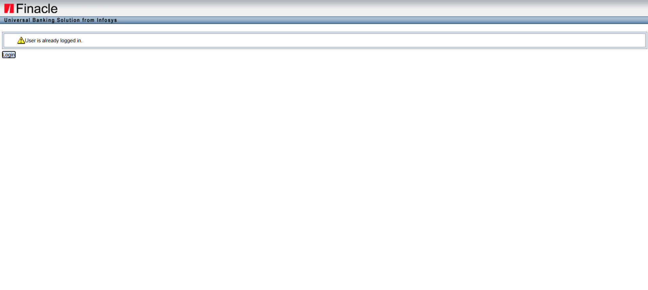
📄 Test Case: TC62_AmendTheInwardBillWhichIsLodge
❌ FAILED:
[2026-03-13 15:10:32] ? Login Failed: User is already logged in.
[2026-03-13 15:10:32] ? Assertion Failure: Finacle Login Error: User is already logged in.
↳ Reason: ❌ ❌ Assertion Failure: Finacle Login Error: User is already logged in.

📸 Screenshot:

⚠️ SKIPPED: runTest
⚠️ SKIPPED: runTest
📄 Test Case: TC60_ModifyTheLodgeBillWhichIscreated
✅ PASSED:
[2026-03-13 10:07:57] ? Exception Occurred: Expected condition failed: waiting for visibility of element located by By.id: menuSelect (tried for 10 second(s) with 500 milliseconds interval)
Build info: version: '4.38.0', revision: '6b412e825c*'
System info: os.name: 'Windows 11', os.arch: 'amd64', os.version: '10.0', java.version: '17.0.12'
Driver info: org.openqa.selenium.edge.EdgeDriver
Capabilities {acceptInsecureCerts: false, browserName: MicrosoftEdge, browserVersion: 145.0.3800.97, fedcm:accounts: true, goog:processID: 21800, ms:edgeOptions: {debuggerAddress: localhost:52710}, msedge: {msedgedriverVersion: 145.0.3800.97 (f4c49d5241f1..., userDataDir: C:\Users\chris\AppData\Loca...}, networkConnectionEnabled: false, pageLoadStrategy: normal, platformName: windows, proxy: Proxy(), se:cdp: ws://localhost:52710/devtoo..., se:cdpVersion: 145.0.3800.97, setWindowRect: true, strictFileInteractability: false, timeouts: {implicit: 0, pageLoad: 300000, script: 30000}, unhandledPromptBehavior: dismiss and notify, webauthn:extension:credBlob: true, webauthn:extension:largeBlob: true, webauthn:extension:minPinLength: true, webauthn:extension:prf: true, webauthn:virtualAuthenticators: true}
Session ID: a38f604fc0d228f72ba6703479927ea7

📄 Test Case: TC63_DishonorOfInwardBillWhichIsAmended
❌ FAILED:
[2026-03-13 15:11:06] ? Login Failed: User is already logged in.
[2026-03-13 15:11:06] ? Assertion Failure: Finacle Login Error: User is already logged in.
[2026-03-13 15:11:17] Bill ID - 003B0503_2025 modified successfully.
[2026-03-13 15:11:38] ? Login Failed: User is already logged in.
[2026-03-13 15:11:38] ? Assertion Failure: Finacle Login Error: User is already logged in.
↳ Reason: ❌ ❌ Assertion Failure: Finacle Login Error: User is already logged in.

📸 Screenshot:

============================================================
📊 Suite Summary: MIIBTests
===============================================
MIIBTests
Total tests run: 9, Passes: 1, Failures: 4, Skips: 2
===============================================
⏱️ Total Duration: 02 min 10 sec

